Torque

Name: ________________________

Objectives:
- Describe the factors that determine whether two objects will balance each other
- Predict how changing the position of a mass on the balance will affect the motion of the balance
- Use a balance to the find the masses of unknown objects

- Open the PhET Simulation Balancing Act https://phet.colorado.edu/sims/html/balancing-act/latest/balancing-act_en.html
- Choose “Intro” tab. Play around with the simulation for a few minutes to understand/ explore the functionalities of the different components.
- To check if the wooden board is balanced, remove supports under the board by toggling the switch at bottom of the screen to right.

Case-1:
Place 5 kg fire extinguisher at 2 m mark to the left of the pivot. Where should you place the 10 kg trash can to balance the board? Show your calculations.
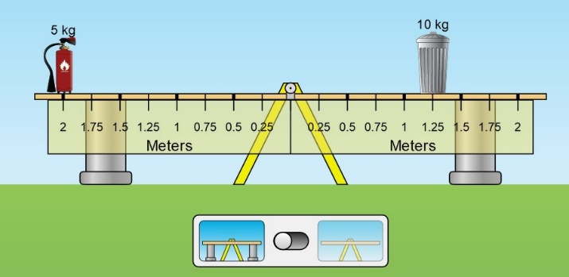

Case-2:
Consider this situation without using the simulation:

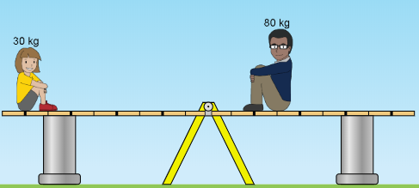

- Predict what will happen when the supports are removed and explain your reasoning.
- Predict what will happen if the 80 kg adult was further from the pivot (more right) and explain your reasoning.
- Predict what will happen if the 30 kg child was closer to the pivot (more right) and explain your reasoning.
- Test your predictions in the Balance Lab. Make notes about any ideas you have that need to be changed.
- What are some rules you could use to make predictions for other situations where masses are on a balance?
- Test your rules with some situations in the lab. Make corrections if needed, then show evidence that your rules work.

Finding unknown masses
Choose “Balance Lab” tab. Select the following options in right corner of the screen:
Mass Labels, Level, Rulers
In the “Bricks” section on the right of the screen, click on the right arrow. Keep on clicking to the right until you see “Mystery Objects”.
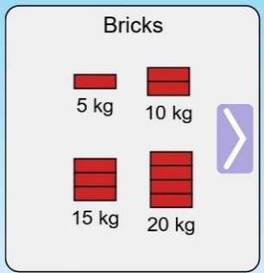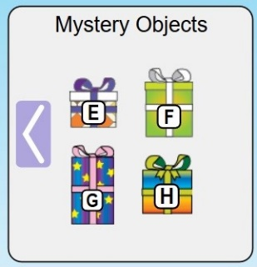
Find out the mass of each of the Mystery Objects “E”, “F”, and “G” by balancing each of these against the bricks of known masses.
For each Mystery Object, paste a screenshot of balanced seesaw and show all calculation steps.

Mystery Object “E”
Screenshot of balanced seesaw:
Calculations:

Mystery Object “F”
Screenshot of balanced seesaw:
Calculations:

Mystery Object “G”
Screenshot of balanced seesaw:
Calculations:

